

Final Group project

PROG8790 | Android Wear Development



Nithish Jagadeesan - 8875048

Shubham Sunilkumar Pandey - 8788878

Arpitkumar Solanki - 8866682

HomeCareSquad – Professional home services at one place

Group 11

Contents

1. Output Screenshots: 2

2. Java Code: 9

3. XML Code: 31

# Output Screenshots:

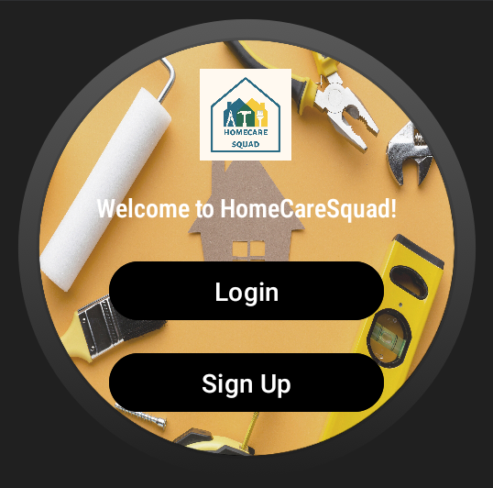

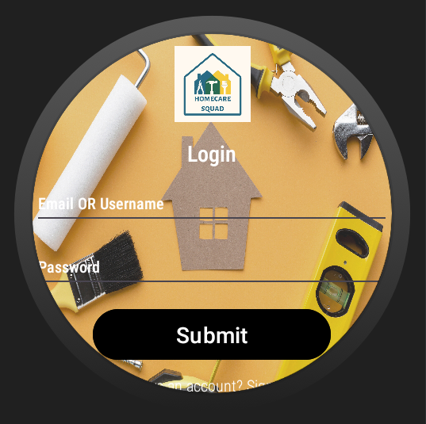

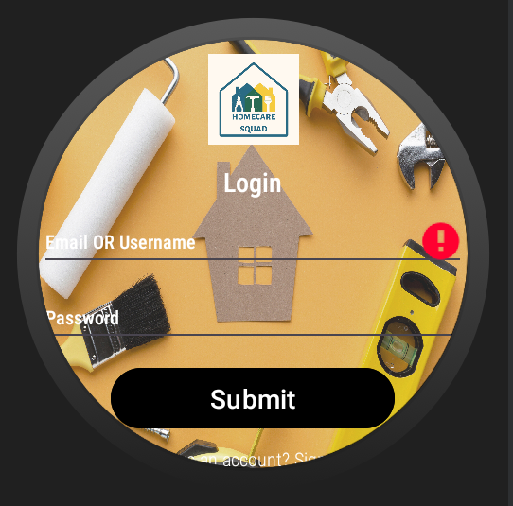

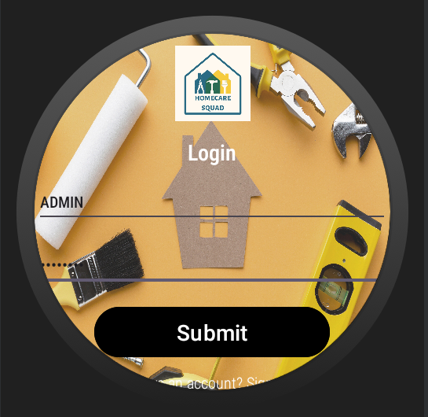



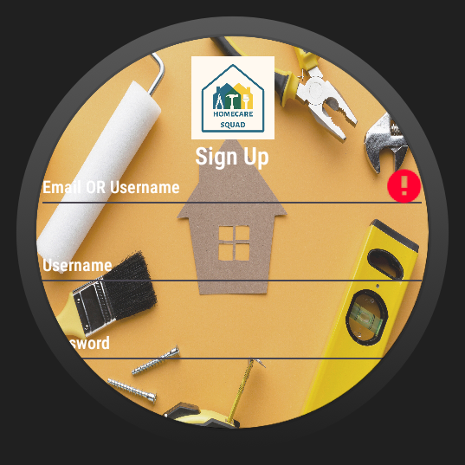







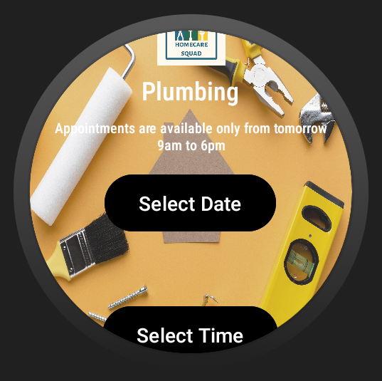

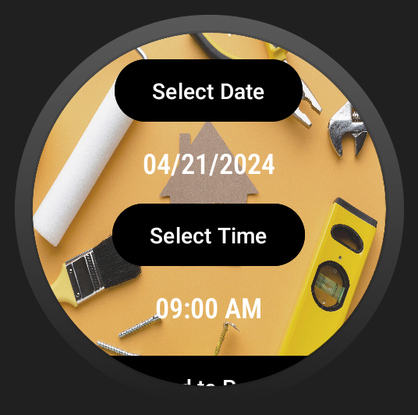

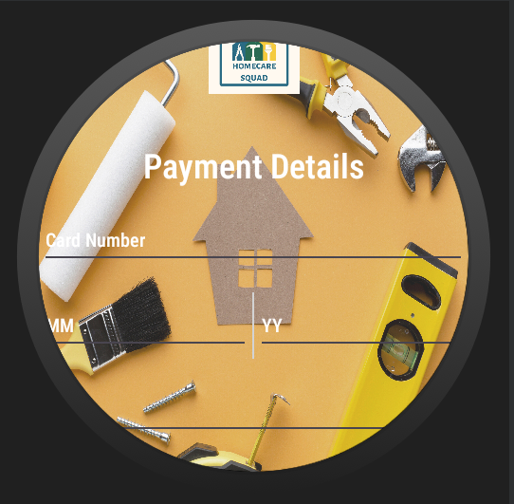

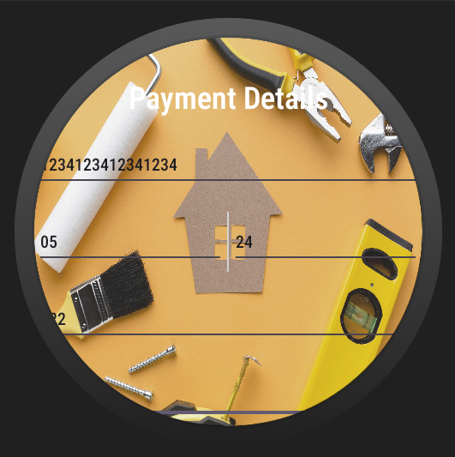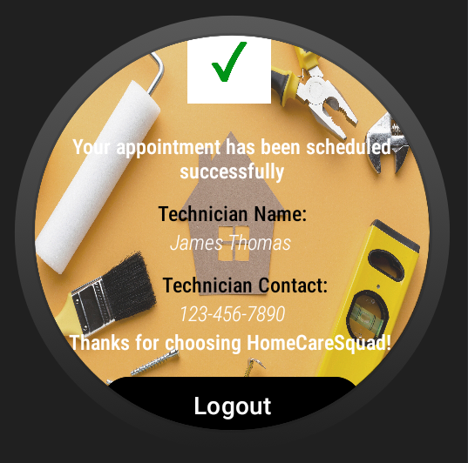

# 2. Java Code:

1. **AppointmentActivity.java:**

**//creating a package called homecaresquad  
package com.example.homecaresquad;  
  
//importing required functions  
import android.app.DatePickerDialog;  
import android.app.TimePickerDialog;  
import android.content.Intent;  
import android.content.SharedPreferences;  
import android.os.Bundle;  
import android.preference.PreferenceManager;  
import android.view.View;  
import android.widget.Button;  
import android.widget.DatePicker;  
import android.widget.TextView;  
import android.widget.TimePicker;  
import android.widget.Toast;  
import androidx.appcompat.app.AppCompatActivity;  
  
import java.io.Serializable;  
import java.text.SimpleDateFormat;  
import java.util.ArrayList;  
import java.util.Calendar;  
import java.util.HashSet;  
import java.util.List;  
import java.util.Locale;  
import java.util.Set;  
  
//creating AppointmentActivity  
public class AppointmentActivity extends AppCompatActivity {  
  
 //declaring required variables  
 private TextView serviceNameTextView;  
 private TextView selectedDateTextView;  
 private TextView selectedTimeTextView;  
 private Button dateButton;  
 private Button timeButton;  
 private Button submitButton;  
 private List<Service> selectedServices = new ArrayList<>();  
  
 private DatePickerDialog.OnDateSetListener dateSetListener;  
 private TimePickerDialog.OnTimeSetListener timeSetListener;  
 private Calendar calendar;  
  
 //oncreate method to initailize tasks when the activity is created  
 @Override  
 protected void onCreate(Bundle savedInstanceState) {  
 super.onCreate(savedInstanceState);  
 setContentView(R.layout.*activity_appointment*);  
  
 //required variables  
 serviceNameTextView = findViewById(R.id.*serviceNameTextView*);  
 selectedDateTextView = findViewById(R.id.*selectedDateTextView*);  
 selectedTimeTextView = findViewById(R.id.*selectedTimeTextView*);  
 dateButton = findViewById(R.id.*dateButton*);  
 timeButton = findViewById(R.id.*timeButton*);  
 submitButton = findViewById(R.id.*submitAppointmentButton*);  
  
 //retrieving selected services from Intent  
 String serviceName = getIntent().getStringExtra("serviceName");  
 double cost = getIntent().getDoubleExtra("cost", 0.0);  
 selectedServices.add(new Service(serviceName, cost, cost, cost));  
  
 //displaying the selected service name  
 serviceNameTextView.setText(serviceName);  
 calendar = Calendar.*getInstance*();  
  
 //declaring date picker dialog  
 dateSetListener = new DatePickerDialog.OnDateSetListener() {  
 @Override  
 public void onDateSet(DatePicker view, int year, int month, int dayOfMonth) {  
 calendar.set(Calendar.*YEAR*, year);  
 calendar.set(Calendar.*MONTH*, month);  
 calendar.set(Calendar.*DAY_OF_MONTH*, dayOfMonth);  
 updateDateLabel();  
 }  
 };  
  
 //declaring time picker dialog  
 timeSetListener = new TimePickerDialog.OnTimeSetListener() {  
 @Override  
 public void onTimeSet(TimePicker view, int hourOfDay, int minute) {  
 calendar.set(Calendar.*HOUR_OF_DAY*, hourOfDay);  
 calendar.set(Calendar.*MINUTE*, minute);  
 updateTimeLabel();  
 }  
 };  
  
 //date button functionality  
 dateButton.setOnClickListener(new View.OnClickListener() {  
 @Override  
 public void onClick(View v) {  
 //getting current calendar instance  
 Calendar currentDate = Calendar.*getInstance*();  
  
 //setting minimum date to tomorrow (current date + 1)  
 currentDate.add(Calendar.*DAY_OF_MONTH*, 1);  
  
 //checking if current date is within the allowed range  
 if (calendar.getTimeInMillis() < currentDate.getTimeInMillis()) {  
 //creating DatePickerDialog with minimum date set  
 DatePickerDialog datePickerDialog = new DatePickerDialog(AppointmentActivity.this, dateSetListener,  
 currentDate.get(Calendar.*YEAR*),  
 currentDate.get(Calendar.*MONTH*),  
 currentDate.get(Calendar.*DAY_OF_MONTH*));  
  
 //showing the DatePickerDialog  
 datePickerDialog.show();  
 } else {  
 //showing error message on selectedDateTextView  
 selectedDateTextView.setError("Please select a date from tomorrow onwards.");  
 }  
 }  
 });  
  
 //time button functionality  
 timeButton.setOnClickListener(new View.OnClickListener() {  
 @Override  
 public void onClick(View v) {  
 //getting current calendar instance  
 Calendar currentTime = Calendar.*getInstance*();  
  
 //setting the minimum time to 9:00 AM  
 currentTime.set(Calendar.*HOUR_OF_DAY*, 9);  
 currentTime.set(Calendar.*MINUTE*, 0);  
  
 //setting the maximum time to 6:00 PM  
 Calendar maxTime = Calendar.*getInstance*();  
 maxTime.set(Calendar.*HOUR_OF_DAY*, 18);  
 maxTime.set(Calendar.*MINUTE*, 0);  
  
 //checking if current time is within the allowed range  
 if (currentTime.getTimeInMillis() < maxTime.getTimeInMillis()) {  
 //creating TimePickerDialog with current time and restricted time range  
 TimePickerDialog timePickerDialog = new TimePickerDialog(AppointmentActivity.this, timeSetListener,  
 currentTime.get(Calendar.*HOUR_OF_DAY*),  
 currentTime.get(Calendar.*MINUTE*),  
 false);  
  
 //setting the range of selectable times  
 timePickerDialog.updateTime(currentTime.get(Calendar.*HOUR_OF_DAY*), currentTime.get(Calendar.*MINUTE*));  
  
 //showing the TimePickerDialog  
 timePickerDialog.show();  
 } else {  
 //showing error message on selectedTimeTextView  
 selectedTimeTextView.setError("Sorry, appointment times are available only from 9am until 6pm");  
 }  
 }  
 });  
  
 //submit button functionality  
 submitButton.setOnClickListener(new View.OnClickListener() {  
 @Override  
 public void onClick(View v) {  
 //getting the selected date and time  
 String selectedDate = selectedDateTextView.getText().toString();  
 String selectedTime = selectedTimeTextView.getText().toString();  
  
 //saving appointment details in SharedPreferences  
 saveAppointment(selectedDate, selectedTime);  
  
 //proceeding to payment  
 startActivity(new Intent(AppointmentActivity.this, PaymentActivity.class));  
 }  
 });  
  
  
 }  
  
 //method to update date label  
 private void updateDateLabel() {  
 String dateFormat = "MM/dd/yyyy";  
 SimpleDateFormat sdf = new SimpleDateFormat(dateFormat, Locale.*US*);  
 selectedDateTextView.setText(sdf.format(calendar.getTime()));  
 }  
  
 //method to update time label  
 private void updateTimeLabel() {  
 String timeFormat = "hh:mm a";  
 SimpleDateFormat sdf = new SimpleDateFormat(timeFormat, Locale.*US*);  
 selectedTimeTextView.setText(sdf.format(calendar.getTime()));  
 }  
  
 //method to save appointment  
 private void saveAppointment(String selectedDate, String selectedTime) {  
 SharedPreferences sharedPreferences = PreferenceManager.*getDefaultSharedPreferences*(this);  
 SharedPreferences.Editor editor = sharedPreferences.edit();  
 Set<String> serviceSet = new HashSet<>();  
 for (Service service : selectedServices) {  
 serviceSet.add(service.getName() + "," + service.getBasicCost() + "," + service.getStandardCost() + "," + service.getPremiumCost());  
 }  
 editor.putStringSet("selectedServices", serviceSet);  
 editor.putString("selectedDate", selectedDate);  
 editor.putString("selectedTime", selectedTime);  
 editor.apply();  
 }  
}**

1. **ConfirmationActivity.java:**

//creating a package called homecaresquad  
package com.example.homecaresquad;  
  
//importing required functions  
import android.content.Intent;  
import android.os.Bundle;  
import android.util.Log;  
import android.view.View;  
import android.widget.Button;  
import android.widget.TextView;  
import androidx.appcompat.app.AppCompatActivity;  
import java.util.Random;  
  
//creating ConfirmationActivity  
public class ConfirmationActivity extends AppCompatActivity {  
  
 //oncreate method to initailize tasks when the activity is created  
 @Override  
 protected void onCreate(Bundle savedInstanceState) {  
 super.onCreate(savedInstanceState);  
 setContentView(R.layout.*activity_confirmation*);  
  
 //debug statement  
 Log.*d*("ConfirmationActivity", "onCreate()");  
  
 //retrieving appointment details from Intent extras  
 Bundle extras = getIntent().getExtras();  
 if (extras != null) {  
 String selectedDate = extras.getString("selectedDate", "");  
 String selectedTime = extras.getString("selectedTime", "");  
  
 //debug statement  
 Log.*d*("ConfirmationActivity", "Selected Date: " + selectedDate);  
 Log.*d*("ConfirmationActivity", "Selected Time: " + selectedTime);  
  
 //generating random technician name and mobile number  
 String technicianName = generateRandomTechnicianName();  
 String technicianMobile = generateRandomMobileNumber();  
  
 //debug statement  
 Log.*d*("ConfirmationActivity", "Technician Name: " + technicianName);  
 Log.*d*("ConfirmationActivity", "Technician Mobile: " + technicianMobile);  
  
 //TextView technicianTextView = findViewById(R.id.technicianTextView);  
  
 //setting technician name and mobile number  
 String technicianDetails = "Technician: " + technicianName + " - " + technicianMobile;  
 //technicianTextView.setText(technicianDetails);  
 }  
  
 //declaring logout button  
 Button logoutButton = findViewById(R.id.*logoutButton*);  
  
 //setting OnClickListener for the logout button  
 logoutButton.setOnClickListener(new View.OnClickListener() {  
 @Override  
 public void onClick(View v) {  
 //creating an Intent to navigate to MainActivity  
 Intent intent = new Intent(ConfirmationActivity.this, MainActivity.class);  
 startActivity(intent);  
 finish();  
 }  
 });  
 }  
  
  
 //method to generate a random technician name  
 private String generateRandomTechnicianName() {  
 String[] technicianNames = {"Peter Parker", "John Wick", "Edward Stark", "Jake Thompson"};  
 Random random = new Random();  
 int index = random.nextInt(technicianNames.length);  
 return technicianNames[index];  
 }  
  
 //method to generate a random mobile number  
 private String generateRandomMobileNumber() {  
 Random random = new Random();  
 int firstPart = random.nextInt(900) + 100;  
 int secondPart = random.nextInt(900) + 100;  
 int thirdPart = random.nextInt(9000) + 1000;  
 return String.*format*("%d-%d-%04d", firstPart, secondPart, thirdPart);  
 }  
}

1. **LoginActivity.java:**

//creating a package called homecaresquad  
package com.example.homecaresquad;  
  
//importing required functions  
import android.content.Intent;  
import android.os.Bundle;  
import android.view.View;  
import android.widget.Button;  
import android.widget.EditText;  
import android.widget.TextView;  
import android.widget.Toast;  
import androidx.appcompat.app.AppCompatActivity;  
  
//creating LoginActivity  
public class LoginActivity extends AppCompatActivity {  
  
 //declaring required variables  
 private EditText emailField;  
 private EditText passwordField;  
  
 //oncreate method to initailize tasks when the activity is created  
 @Override  
 protected void onCreate(Bundle savedInstanceState) {  
 super.onCreate(savedInstanceState);  
 setContentView(R.layout.*activity_login*);  
  
 emailField = findViewById(R.id.*emailField*);  
 passwordField = findViewById(R.id.*passwordField*);  
  
 //submit button functionality  
 Button submitBtn = findViewById(R.id.*submitButton*);  
 submitBtn.setOnClickListener(new View.OnClickListener() {  
 @Override  
 public void onClick(View v) {  
 if (validateFields()) {  
 Intent intent = new Intent(LoginActivity.this, ServiceListingActivity.class);  
 startActivity(intent);  
 }  
 else {  
 Toast.*makeText*(LoginActivity.this, "Invalid email or password", Toast.*LENGTH_SHORT*).show();  
 }  
 }  
 });  
  
 //signUpTextView functionality  
 TextView signUpTextView = findViewById(R.id.*signUpTextView*);  
 signUpTextView.setOnClickListener(new View.OnClickListener() {  
 @Override  
 public void onClick(View v) {  
 Intent intent = new Intent(LoginActivity.this, SignUpActivity.class);  
 startActivity(intent);  
 }  
 });  
 }  
  
 //method to validate all fields  
 private boolean validateFields() {  
 String email = emailField.getText().toString().trim();  
 String password = passwordField.getText().toString().trim();  
  
 //email validation  
 if (email.isEmpty()) {  
 emailField.setError("Email is required");  
 return false;  
 }  
  
 //password validation  
 if (password.isEmpty()) {  
 passwordField.setError("Password is required");  
 return false;  
 }  
  
 //default credentials validation  
 if (!email.equals("ADMIN") || !password.equals("PASSWORD")) {  
 Toast.*makeText*(LoginActivity.this, "Invalid email or password", Toast.*LENGTH_SHORT*).show();  
 return false;  
 }  
  
 return true;  
 }  
  
}

1. **MainActivity.java:**

//creating a package called homecaresquad  
package com.example.homecaresquad;  
  
//importing required functions  
import androidx.appcompat.app.AppCompatActivity;  
  
import android.content.Intent;  
import android.content.SharedPreferences;  
import android.os.Bundle;  
import android.preference.PreferenceManager;  
import android.view.View;  
  
import com.example.homecaresquad.databinding.ActivityMainBinding;  
  
import java.util.ArrayList;  
import java.util.Set;  
  
//creating MainActivity  
public class MainActivity extends AppCompatActivity {  
  
 //declaring required variables  
 private ActivityMainBinding binding;  
  
 //oncreate method to initailize tasks when the activity is created  
 @Override  
 protected void onCreate(Bundle savedInstanceState) {  
 super.onCreate(savedInstanceState);  
 binding = ActivityMainBinding.*inflate*(getLayoutInflater());  
 View view = binding.getRoot();  
 setContentView(view);  
  
 //setting OnClickListener for loginButton  
 binding.loginButton.setOnClickListener(new View.OnClickListener() {  
 @Override  
 public void onClick(View v) {  
 // Open LoginActivity when loginButton is clicked  
 openLoginPage();  
 }  
 });  
  
 //declaring OnClickListener for loginButton  
 binding.signupButton.setOnClickListener(new View.OnClickListener() {  
 @Override  
 public void onClick(View v) {  
 // Open LoginActivity when loginButton is clicked  
 openSignUpPage();  
 }  
 });  
 }  
  
 //method to open login page  
 private void openLoginPage() {  
 Intent intent = new Intent(this, LoginActivity.class);  
 startActivity(intent);  
 }  
  
 //method to open sign up page  
 private void openSignUpPage() {  
 Intent intent = new Intent(this, SignUpActivity.class);  
 startActivity(intent);  
 }  
  
}

1. **PaymentActivity.java:**

//creating a package called homecaresquad  
package com.example.homecaresquad;  
  
//importing required functions  
import android.annotation.SuppressLint;  
import android.content.Context;  
import android.content.Intent;  
import android.content.SharedPreferences;  
import android.os.Bundle;  
import android.os.Handler;  
import android.preference.PreferenceManager;  
import android.view.View;  
import android.widget.Button;  
import android.widget.EditText;  
import android.widget.ProgressBar;  
import android.widget.TextView;  
import android.widget.Toast;  
  
import androidx.appcompat.app.AppCompatActivity;  
  
import java.util.Calendar;  
  
//creating PaymentActivity  
public class PaymentActivity extends AppCompatActivity {  
  
 //declaring required variables  
 private TextView confirmationMessageTextView;  
 private Button confirmAppointmentButton;  
 private ProgressBar circularProgressView;  
 private EditText cardNumberField;  
 private EditText monthField;  
 private EditText yearField;  
 private EditText cvvField;  
 private EditText cardHolderNameField;  
 private boolean isAppointmentConfirmed = false;  
 private SharedPreferences sharedPreferences;  
 private static final String *PREFS_NAME* = "MyPrefs";  
 private static final String *KEY_SELECTED_DATE* = "selectedDate";  
 private static final String *KEY_SELECTED_TIME* = "selectedTime";  
 private String selectedDate;  
 private String selectedTime;  
  
 //oncreate method to initailize tasks when the activity is created  
 @SuppressLint("MissingInflatedId")  
 @Override  
 protected void onCreate(Bundle savedInstanceState) {  
 super.onCreate(savedInstanceState);  
 setContentView(R.layout.*activity_payment*);  
  
 //initializing editText fields  
 confirmationMessageTextView = findViewById(R.id.*confirmationMessageTextView*);  
 confirmAppointmentButton = findViewById(R.id.*confirmAppointmentButton*);  
 circularProgressView = findViewById(R.id.*circularProgressView*);  
  
 //initializing editText fields  
 cardNumberField = findViewById(R.id.*cardNumberField*);  
 monthField = findViewById(R.id.*monthField*);  
 yearField = findViewById(R.id.*yearField*);  
 cvvField = findViewById(R.id.*cvvField*);  
 cardHolderNameField = findViewById(R.id.*cardHolderNameField*);  
  
 //initializing SharedPreferences  
 sharedPreferences = getSharedPreferences(*PREFS_NAME*, Context.*MODE_PRIVATE*);  
  
 //retrieving selectedDate and selectedTime from SharedPreferences  
 selectedDate = sharedPreferences.getString(*KEY_SELECTED_DATE*, "");  
 selectedTime = sharedPreferences.getString(*KEY_SELECTED_TIME*, "");  
  
 //setting Onclick listener for confirm appointment button  
 confirmAppointmentButton.setOnClickListener(new View.OnClickListener() {  
 @Override  
 public void onClick(View v) {  
 //form validations  
 if (validateForm()) {  
 //circular progress view  
 showCircularProgress(true);  
  
 //appointment booking process  
 new Handler().postDelayed(new Runnable() {  
 @Override  
 public void run() {  
 //confirmation message and proceed to next activity  
 String message = "Your appointment has been booked.\nDate: " + selectedDate + "\nTime: " + selectedTime;  
 showConfirmationMessage(message);  
 Toast.*makeText*(PaymentActivity.this, message, Toast.*LENGTH_LONG*).show();  
 startActivity(new Intent(PaymentActivity.this, ConfirmationActivity.class));  
 }  
 }, 1000);  
 }  
 }  
 });  
 }  
  
 //method for form validation  
 private boolean validateForm() {  
 //retrieving input values from EditText fields  
 String cardNumber = cardNumberField.getText().toString().trim();  
 String month = monthField.getText().toString().trim();  
 String year = yearField.getText().toString().trim();  
 String cvv = cvvField.getText().toString().trim();  
 String cardHolderName = cardHolderNameField.getText().toString().trim();  
  
 //validating card number format: XXXXXXXXXXXXXXXX  
 if (!cardNumber.matches("\\d{16}")) {  
 cardNumberField.setError("Invalid card number format");  
 return false;  
 }  
  
 //validating month format: XX (it should be 1 to 12)  
 int inputMonth = Integer.*parseInt*(month);  
 if (inputMonth < 1 || inputMonth > 12) {  
 monthField.setError("Invalid month format");  
 return false;  
 }  
  
 //validating year format: XX (should be greater than 23)  
 int inputYear = Integer.*parseInt*(year);  
 if (inputYear <= 23) {  
 yearField.setError("Invalid year format");  
 return false;  
 }  
  
 //validating expiry date  
 if ((inputMonth == 4 && inputYear == 24) || (inputMonth == 3 && inputYear == 24) || (inputMonth == 2 && inputYear == 24)|| (inputMonth == 1 && inputYear == 24)) {  
 monthField.setError("Invalid month-year combination");  
 yearField.setError("Invalid month-year combination");  
 return false;  
 }  
  
 //current date and time  
 Calendar currentDate = Calendar.*getInstance*();  
 currentDate.add(Calendar.*DAY_OF_MONTH*, 1);  
  
 int currentMonth = currentDate.get(Calendar.*MONTH*) + 1;  
 int currentYear = currentDate.get(Calendar.*YEAR*) % 100;  
  
 //validating expiry date: should not be earlier than tomorrow  
 if (inputYear < currentYear || (inputYear == currentYear && inputMonth < currentMonth)) {  
 Toast.*makeText*(PaymentActivity.this, "Expiry date cannot be earlier than tomorrow", Toast.*LENGTH_SHORT*).show();  
 return false;  
 }  
  
 //validating CVV format: XXX  
 if (!cvv.matches("\\d{3}")) {  
 cvvField.setError("Invalid CVV format");  
 return false;  
 }  
  
 //validating cardholder name: normal text  
 if (cardHolderName.isEmpty()) {  
 cardHolderNameField.setError("Cardholder name is required");  
 return false;  
 }  
 return true;  
 }  
  
  
 //method to show/hide circular progress view  
 private void showCircularProgress(boolean show) {  
 if (show) {  
 circularProgressView.setVisibility(View.*VISIBLE*);  
 } else {  
 circularProgressView.setVisibility(View.*GONE*);  
 }  
 }  
  
 //method to show confirmation message with date and time  
 private void showConfirmationMessage(String message) {  
 confirmationMessageTextView.setText(message);  
 isAppointmentConfirmed = true;  
 showCircularProgress(false);  
 }  
  
 //method to save instance state  
 @Override  
 protected void onSaveInstanceState(Bundle outState) {  
 super.onSaveInstanceState(outState);  
 outState.putBoolean("isAppointmentConfirmed", isAppointmentConfirmed);  
 }  
  
 //method to restore instance state  
 @Override  
 protected void onRestoreInstanceState(Bundle savedInstanceState) {  
 super.onRestoreInstanceState(savedInstanceState);  
 isAppointmentConfirmed = savedInstanceState.getBoolean("isAppointmentConfirmed");  
 if (isAppointmentConfirmed) {  
 //confirmation message if appointment is already confirmed  
 String message = "Your appointment has been booked.\nDate: " + selectedDate + "\nTime: " + selectedTime;  
 showConfirmationMessage(message);  
 }  
 }  
}

1. **Service.java:**

//creating a package called homecaresquad  
package com.example.homecaresquad;  
  
//importing required functions  
import android.os.Parcel;  
import android.os.Parcelable;  
  
//creating a class Service  
public class Service implements Parcelable {  
 //declaring required variables  
 private String name;  
 private int imageResourceId;  
 private double basicCost;  
 private double standardCost;  
 private double premiumCost;  
  
 //constructor  
 public Service(String name, double basicCost, double standardCost, double premiumCost) {  
 this.name = name;  
 this.basicCost = basicCost;  
 this.standardCost = standardCost;  
 this.premiumCost = premiumCost;  
 }  
  
 //constructor for Parcel  
 protected Service(Parcel in) {  
 name = in.readString();  
 imageResourceId = in.readInt();  
 basicCost = in.readDouble();  
 standardCost = in.readDouble();  
 premiumCost = in.readDouble();  
 }  
  
 public static final Creator<Service> *CREATOR* = new Creator<Service>() {  
 @Override  
 public Service createFromParcel(Parcel in) {  
 return new Service(in);  
 }  
  
 @Override  
 public Service[] newArray(int size) {  
 return new Service[size];  
 }  
 };  
  
  
 //getters and setters  
 public String getName() {  
 return name;  
 }  
  
 public int getImageResourceId() {  
 return imageResourceId;  
 }  
  
 public double getBasicCost() {  
 return basicCost;  
 }  
  
 public double getStandardCost() {  
 return standardCost;  
 }  
  
 public double getPremiumCost() {  
 return premiumCost;  
 }  
  
 @Override  
 public int describeContents() {  
 return 0;  
 }  
  
 @Override  
 public void writeToParcel(Parcel parcel, int flags) {  
 parcel.writeString(name);  
 parcel.writeInt(imageResourceId);  
 parcel.writeDouble(basicCost);  
 parcel.writeDouble(standardCost);  
 parcel.writeDouble(premiumCost);  
 }  
}

1. **ServiceAdapter.java:**

//creating a package called homecaresquad  
package com.example.homecaresquad;  
  
//importing required functions  
import android.content.Context;  
import android.util.Log;  
import android.view.LayoutInflater;  
import android.view.View;  
import android.view.ViewGroup;  
import android.widget.TextView;  
import android.widget.Toast;  
import androidx.annotation.NonNull;  
import androidx.recyclerview.widget.RecyclerView;  
import java.util.List;  
  
//creating an adapter for service listing  
public class ServiceAdapter extends RecyclerView.Adapter<ServiceAdapter.ViewHolder> {  
  
 //declaring required variables  
 private List<Service> services;  
 private Context context;  
 private OnItemClickListener listener;  
  
 //constructor  
 public ServiceAdapter(Context context, List<Service> services) {  
 this.context = context;  
 this.services = services;  
 }  
  
 //interface for item click listener  
 public interface OnItemClickListener {  
 void onItemClick(int position);  
 }  
  
 //setter method for the listener  
 public void setOnItemClickListener(OnItemClickListener listener) {  
 this.listener = listener;  
 }  
  
 //view holder to hold the item_service view  
 @NonNull  
 @Override  
 public ViewHolder onCreateViewHolder(@NonNull ViewGroup parent, int viewType) {  
 View view = LayoutInflater.*from*(parent.getContext()).inflate(R.layout.*item_service*, parent, false);  
 return new ViewHolder(view);  
 }  
  
 //holder to bind the services  
 @Override  
 public void onBindViewHolder(@NonNull ViewHolder holder, int position) {  
 Service service = services.get(position);  
 holder.bind(service);  
  
 //setting onclick listener for the item view  
 holder.itemView.setOnClickListener(new View.OnClickListener() {  
 @Override  
 public void onClick(View v) {  
 if (listener != null) {  
 listener.onItemClick(position);  
 Log.*d*("ServiceDetailsAdapter", "Clicked service: " + service.getName());  
  
 }  
 }  
 });  
 }  
  
 //method to get the item count  
 @Override  
 public int getItemCount() {  
 if (services != null) {  
 return services.size();  
 } else {  
 return 0;  
 }  
 }  
  
 //static method to hold the recycler view  
 public static class ViewHolder extends RecyclerView.ViewHolder {  
 private TextView textView;  
 public ViewHolder(@NonNull View itemView) {  
 super(itemView);  
 textView = itemView.findViewById(R.id.*service_name*);  
 }  
 public void bind(Service service) {  
 textView.setText(service.getName());  
 }  
 }  
  
}

1. **ServiceDetailsActivity.java:**

//creating a package called homecaresquad  
package com.example.homecaresquad;  
  
//importing required functions  
import androidx.appcompat.app.AppCompatActivity;  
import androidx.recyclerview.widget.LinearLayoutManager;  
import androidx.recyclerview.widget.RecyclerView;  
  
import android.os.Bundle;  
  
import java.util.ArrayList;  
import java.util.List;  
  
//creating Service  
public class ServiceDetailsActivity extends AppCompatActivity {  
  
 //declaring required variables  
 private RecyclerView recyclerView;  
 private ServiceDetailsAdapter adapter;  
 private List<Service> services;  
  
 //oncreate method to initailize tasks when the activity is created  
 @Override  
 protected void onCreate(Bundle savedInstanceState) {  
 super.onCreate(savedInstanceState);  
 setContentView(R.layout.*activity_service_details*);  
  
 recyclerView = findViewById(R.id.*service_details_recycler_view*);  
 recyclerView.setLayoutManager(new LinearLayoutManager(this));  
  
 //initializing services  
 services = new ArrayList<>();  
 services.add(new Service("Plumbing", 29.99, 39.99, 49.99));  
 services.add(new Service("Cleaning", 24.99, 34.99, 44.99));  
 services.add(new Service("Repairs", 19.99, 29.99, 39.99));  
 services.add(new Service("Gardening", 129.99, 139.99, 149.99));  
 services.add(new Service("Home Spa", 49.99, 59.99, 69.99));  
 services.add(new Service("Electrical", 39.99, 59.99, 79.99));  
  
 //initializing adapter with context and services  
 adapter = new ServiceDetailsAdapter(this, services);  
  
 //setting adapter to RecyclerView  
 recyclerView.setAdapter(adapter);  
 }  
}

1. **ServiceDetailsAdapter.java:**

//creating a package called homecaresquad  
package com.example.homecaresquad;  
  
//importing required functions  
import android.app.Activity;  
import android.content.Context;  
import android.content.Intent;  
import android.util.Log;  
import android.view.LayoutInflater;  
import android.view.View;  
import android.view.ViewGroup;  
import android.widget.TextView;  
  
import androidx.annotation.NonNull;  
import androidx.recyclerview.widget.RecyclerView;  
  
import java.util.List;  
  
//creating ServiceDetailsActivity  
public class ServiceDetailsAdapter extends RecyclerView.Adapter<ServiceDetailsAdapter.ViewHolder> {  
 //declaring required variables  
 private List<Service> services;  
 private Context context;  
 private Service service;  
  
 //constructor  
 public ServiceDetailsAdapter(Context context, List<Service> services) {  
 this.context = context;  
 this.services = services;  
 }  
  
 //method to hold the item_service_detail view  
 @NonNull  
 @Override  
 public ViewHolder onCreateViewHolder(@NonNull ViewGroup parent, int viewType) {  
 View view = LayoutInflater.*from*(parent.getContext()).inflate(R.layout.*item_service_detail*, parent, false);  
 return new ViewHolder(view);  
 }  
  
 //method to bind the service view  
 @Override  
 public void onBindViewHolder(@NonNull ViewHolder holder, int position) {  
  
 Service service = services.get(position);  
 holder.bind(service);  
  
 //debug statement  
 Log.*d*("ServiceDetailsAdapter", "Bound service: " + service.getName() + " at position: " + position + " with holder: " + holder);  
  
 //setting on click listener for the item  
 holder.itemView.setOnClickListener(new View.OnClickListener() {  
 @Override  
 public void onClick(View v) {  
 //getting the clicked service  
 Service clickedService = services.get(holder.getAdapterPosition());  
  
 //debug statement  
 Log.*d*("ServiceDetailsAdapter", "Clicked service: " + clickedService.getName() + ", Basic Cost: $" + clickedService.getBasicCost() + " at position: " + holder.getAdapterPosition() + " with holder: " + holder);  
  
 //creating an intent to start the AppointmentActivity  
 Intent intent = new Intent(context, AppointmentActivity.class);  
  
 //passing service details to the AppointmentActivity  
 intent.putExtra("serviceName", clickedService.getName());  
 intent.putExtra("basicCost", clickedService.getBasicCost());  
 intent.putExtra("standardCost", clickedService.getStandardCost());  
 intent.putExtra("premiumCost", clickedService.getPremiumCost());  
 context.startActivity(intent);  
 }  
 });  
}  
  
 //method to get the item count  
 @Override  
 public int getItemCount() {  
 return services.size();  
 }  
  
 //method to hold the recycler view  
 public static class ViewHolder extends RecyclerView.ViewHolder {  
 private TextView serviceNameTextView, basicCostTextView, standardCostTextView, premiumCostTextView;  
  
 //method for holding the view  
 public ViewHolder(@NonNull View itemView) {  
 super(itemView);  
 serviceNameTextView = itemView.findViewById(R.id.*service_name*);  
 basicCostTextView = itemView.findViewById(R.id.*basic_cost*);  
 standardCostTextView = itemView.findViewById(R.id.*standard_cost*);  
 premiumCostTextView = itemView.findViewById(R.id.*premium_cost*);  
 }  
  
 //method to bind the service  
 public void bind(Service service) {  
 serviceNameTextView.setText(service.getName());  
 basicCostTextView.setText("Basic Cost: $" + service.getBasicCost());  
 standardCostTextView.setText("Standard Cost: $" + service.getStandardCost());  
 premiumCostTextView.setText("Premium Cost: $" + service.getPremiumCost());  
 }  
  
 }  
  
}

1. **ServiceListingActivity.java:**

//creating a package called homecaresquad  
package com.example.homecaresquad;  
  
//importing required functions  
import androidx.appcompat.app.AppCompatActivity;  
import androidx.recyclerview.widget.LinearLayoutManager;  
import androidx.recyclerview.widget.RecyclerView;  
  
import android.os.Bundle;  
import android.util.Log;  
  
import java.util.ArrayList;  
import java.util.List;  
  
import androidx.appcompat.app.AppCompatActivity;  
import androidx.recyclerview.widget.LinearLayoutManager;  
import androidx.recyclerview.widget.RecyclerView;  
  
import android.content.Intent;  
import android.os.Bundle;  
import android.util.Log;  
import android.view.View;  
  
import java.util.ArrayList;  
import java.util.List;  
  
//creating ServiceListingActivity  
public class ServiceListingActivity extends AppCompatActivity {  
 //declaring required variables  
 private RecyclerView recyclerView;  
 private ServiceAdapter adapter;  
 private List<Service> services;  
  
 //oncreate method to initailize tasks when the activity is created  
 @Override  
 protected void onCreate(Bundle savedInstanceState) {  
 super.onCreate(savedInstanceState);  
 setContentView(R.layout.*activity_service_listing*);  
  
 recyclerView = findViewById(R.id.*recycler_view*);  
 recyclerView.setLayoutManager(new LinearLayoutManager(this));  
  
 //initializing services  
 services = new ArrayList<>();  
 services.add(new Service("Plumbing", 29.99, 39.99, 49.99));  
 services.add(new Service("Cleaning", 24.99, 34.99, 44.99));  
 services.add(new Service("Repairs", 19.99, 29.99, 39.99));  
 services.add(new Service("Gardening", 129.99, 139.99, 149.99));  
 services.add(new Service("Home Spa", 49.99, 59.99, 69.99));  
 services.add(new Service("Electrical", 39.99, 59.99, 79.99));  
  
 //initializing adapter with context and services  
 adapter = new ServiceAdapter(this, services);  
  
 //setting adapter to RecyclerView  
 recyclerView.setAdapter(adapter);  
  
 //setting item click listener for the adapter  
 adapter.setOnItemClickListener(new ServiceAdapter.OnItemClickListener() {  
 @Override  
 public void onItemClick(int position) {  
 //getting the clicked service  
 Service service = services.get(position);  
  
 //navigating to ServiceDetailsActivity with service details  
 Intent intent = new Intent(ServiceListingActivity.this, ServiceDetailsActivity.class);  
 intent.putExtra("serviceName", service.getName());  
 intent.putExtra("basicCost", service.getBasicCost());  
 intent.putExtra("standardCost", service.getStandardCost());  
 intent.putExtra("premiumCost", service.getPremiumCost());  
 startActivity(intent);  
 }  
 });  
  
 }  
}

1. **SignUpActivity.java:**

//creating a package called homecaresquad  
package com.example.homecaresquad;  
  
//importing required variables  
import android.content.Intent;  
import android.content.SharedPreferences;  
import android.os.Bundle;  
import android.util.Patterns;  
import android.view.View;  
import android.widget.Button;  
import android.widget.EditText;  
import android.widget.TextView;  
import android.widget.Toast;  
import androidx.appcompat.app.AppCompatActivity;  
  
import java.util.regex.Pattern;  
  
//creating SignUpActivity  
public class SignUpActivity extends AppCompatActivity {  
  
 //declaring required variables  
 private EditText emailField;  
 private EditText nameField;  
 private EditText passwordField;  
 private EditText confirmPasswordField;  
 private static final String *PREFS_NAME* = "UserPrefs";  
  
 //oncreate method to initailize tasks when the activity is created  
 @Override  
 protected void onCreate(Bundle savedInstanceState) {  
 super.onCreate(savedInstanceState);  
 setContentView(R.layout.*activity_sign_up*);  
  
 //initializing fields  
 emailField = findViewById(R.id.*emailField*);  
 nameField = findViewById(R.id.*nameField*);  
 passwordField = findViewById(R.id.*passwordField*);  
 confirmPasswordField = findViewById(R.id.*confirmPasswordField*);  
  
 //submit button functionality  
 Button submitBtn = findViewById(R.id.*submitButton2*);  
 submitBtn.setOnClickListener(new View.OnClickListener() {  
 @Override  
 public void onClick(View v) {  
 if (validateFields()) {  
 saveCredentials();  
 Toast.*makeText*(SignUpActivity.this, "Account created successfully", Toast.*LENGTH_SHORT*).show();  
 Intent intent = new Intent(SignUpActivity.this, ServiceListingActivity.class);  
 startActivity(intent);  
 }  
 }  
 });  
  
 //loginHereTextView functionality  
 TextView loginHereTextView = findViewById(R.id.*loginHereTextView*);  
 loginHereTextView.setOnClickListener(new View.OnClickListener() {  
 @Override  
 public void onClick(View v) {  
 Intent intent = new Intent(SignUpActivity.this, LoginActivity.class);  
 startActivity(intent);  
 }  
 });  
 }  
  
 //method for validating all fields  
 private boolean validateFields() {  
 String email = emailField.getText().toString().trim();  
 String name = nameField.getText().toString().trim();  
 String password = passwordField.getText().toString().trim();  
 String confirmPassword = confirmPasswordField.getText().toString().trim();  
  
 //email validation  
 if (email.isEmpty()) {  
 emailField.setError("Email is required");  
 return false;  
 }  
  
 if (!isValidEmail(email)) {  
 emailField.setError("Invalid email format");  
 return false;  
 }  
  
 //name validation  
 if (name.isEmpty()) {  
 nameField.setError("Name is required");  
 return false;  
 }  
  
 //password and confirm password validation  
 if (password.isEmpty()) {  
 passwordField.setError("Password is required");  
 return false;  
 }  
  
 if (!password.equals(confirmPassword)) {  
 confirmPasswordField.setError("Passwords do not match");  
 return false;  
 }  
  
 return true;  
 }  
  
 //method to save the credentials  
 private void saveCredentials() {  
 String email = emailField.getText().toString().trim();  
 String password = passwordField.getText().toString().trim();  
  
 SharedPreferences.Editor editor = getSharedPreferences(*PREFS_NAME*, *MODE_PRIVATE*).edit();  
 editor.putString("email", email);  
 editor.putString("password", password);  
 editor.apply();  
 }  
  
 //method to check the pattern of the email  
 private boolean isValidEmail(String email) {  
 Pattern pattern = Patterns.*EMAIL_ADDRESS*;  
 return pattern.matcher(email).matches();  
 }  
}

# 3. XML Code:

1. **activity_appointment.xml:**

<ScrollView xmlns:android="http://schemas.android.com/apk/res/android"  
 xmlns:tools="http://schemas.android.com/tools"  
 android:layout_width="match_parent"  
 android:layout_height="match_parent"  
 xmlns:app="http://schemas.android.com/apk/res-auto">  
  
 <RelativeLayout  
 android:layout_width="match_parent"  
 android:layout_height="wrap_content"  
 android:padding="16dp">  
  
 <!-- Logo -->  
 <ImageView  
 android:id="@+id/logo"  
 android:layout_width="48dp"  
 android:layout_height="48dp"  
 android:layout_marginStart="74dp"  
 android:layout_marginTop="12dp"  
 android:layout_marginBottom="5dp"  
 app:layout_constraintBottom_toTopOf="@id/serviceNameTextView"  
 app:layout_constraintStart_toStartOf="parent"  
 app:layout_constraintTop_toTopOf="parent"  
 app:srcCompat="@drawable/homecaresquad" />  
  
 <!-- Service Name TextView -->  
 <TextView  
 android:id="@+id/serviceNameTextView"  
 android:layout_width="wrap_content"  
 android:layout_height="wrap_content"  
 android:textSize="18sp"  
 android:textColor="@color/white"  
 android:textStyle="bold"  
 android:layout_below="@id/logo"  
 android:layout_centerHorizontal="true"  
 android:layout_marginBottom="5dp"  
 tools:text="@string/service_name_header"/>  
  
 <TextView  
 android:id="@+id/appointmentAvailabilityTextView"  
 android:layout_width="wrap_content"  
 android:layout_height="wrap_content"  
 android:layout_below="@id/serviceNameTextView"  
 android:layout_centerHorizontal="true"  
 android:layout_marginTop="2dp"  
 android:text="@string/appointment_available"  
 android:textAlignment="center"  
 android:textColor="@color/white"  
 android:textSize="10sp"  
 android:textStyle="bold" />  
  
 <!-- Date Button -->  
 <Button  
 android:id="@+id/dateButton"  
 android:layout_width="wrap_content"  
 android:layout_height="wrap_content"  
 android:text="@string/select_date"  
 android:layout_below="@id/appointmentAvailabilityTextView"  
 android:layout_centerHorizontal="true"  
 android:layout_marginTop="10dp"  
 android:backgroundTint="@color/black"/>  
  
 <!-- Display selected date -->  
 <TextView  
 android:id="@+id/selectedDateTextView"  
 android:layout_width="wrap_content"  
 android:layout_height="wrap_content"  
 android:textSize="18sp"  
 android:textColor="@color/white"  
 android:textStyle="bold"  
 android:layout_below="@id/dateButton"  
 android:layout_centerHorizontal="true"  
 android:layout_marginTop="10dp"  
 tools:text="@string/selected_date"/>  
  
 <!-- Time Button -->  
 <Button  
 android:id="@+id/timeButton"  
 android:layout_width="wrap_content"  
 android:layout_height="wrap_content"  
 android:text="@string/select_time"  
 android:layout_below="@id/selectedDateTextView"  
 android:layout_centerHorizontal="true"  
 android:layout_marginTop="10dp"  
 android:backgroundTint="@color/black"/>  
  
 <!-- Display selected time -->  
 <TextView  
 android:id="@+id/selectedTimeTextView"  
 android:layout_width="wrap_content"  
 android:layout_height="wrap_content"  
 android:textSize="18sp"  
 android:textColor="@color/white"  
 android:textStyle="bold"  
 android:layout_below="@id/timeButton"  
 android:layout_centerHorizontal="true"  
 android:layout_marginTop="10dp"  
 tools:text="@string/selected_time"/>  
  
 <!-- Submit button -->  
 <Button  
 android:id="@+id/submitAppointmentButton"  
 android:layout_width="wrap_content"  
 android:layout_height="wrap_content"  
 android:text="@string/proceed_to_payment"  
 android:layout_below="@id/selectedTimeTextView"  
 android:layout_centerHorizontal="true"  
 android:layout_marginTop="15dp"  
 android:backgroundTint="@color/black"/>  
  
 </RelativeLayout>  
</ScrollView>

1. **activity_confirmation.xml:**

<?xml version="1.0" encoding="utf-8"?>  
<ScrollView xmlns:android="http://schemas.android.com/apk/res/android"  
 xmlns:app="http://schemas.android.com/apk/res-auto"  
 xmlns:tools="http://schemas.android.com/tools"  
 android:layout_width="match_parent"  
 android:layout_height="match_parent"  
 android:fillViewport="true">  
  
 <androidx.constraintlayout.widget.ConstraintLayout  
 android:layout_width="match_parent"  
 android:layout_height="wrap_content"  
 android:layout_gravity="center"  
 tools:context=".LoginActivity">  
  
 <!-- Success Tick -->  
 <ImageView  
 android:id="@+id/green_mark_image"  
 android:layout_width="48dp"  
 android:layout_height="48dp"  
 android:layout_marginStart="88dp"  
 android:layout_marginTop="5dp"  
 android:layout_marginBottom="16dp"  
 app:layout_constraintBottom_toTopOf="@id/scheduledTextView"  
 app:layout_constraintStart_toStartOf="parent"  
 app:layout_constraintTop_toTopOf="parent"  
 app:srcCompat="@drawable/green_tick" />  
  
 <!-- Appointment confirmation TextView -->  
 <TextView  
 android:id="@+id/scheduledTextView"  
 android:layout_width="wrap_content"  
 android:layout_height="wrap_content"  
 android:text="@string/appointment_confirmation"  
 android:textAlignment="center"  
 android:textColor="@color/white"  
 android:textSize="12sp"  
 android:textStyle="bold"  
 app:layout_constraintBottom_toTopOf="@id/technicianNameLabelTextView"  
 app:layout_constraintEnd_toEndOf="parent"  
 app:layout_constraintHorizontal_bias="0.0"  
 app:layout_constraintStart_toStartOf="parent"  
 app:layout_constraintTop_toBottomOf="@id/green_mark_image" />  
  
 <!-- Technician Name TextView -->  
 <TextView  
 android:id="@+id/technicianNameLabelTextView"  
 android:layout_width="wrap_content"  
 android:layout_height="wrap_content"  
 android:layout_marginTop="8dp"  
 android:text="@string/technician_name"  
 android:textAlignment="center"  
 android:textColor="@color/black"  
 android:textSize="12sp"  
 android:textStyle="bold"  
 app:layout_constraintBottom_toTopOf="@id/technicianNameTextView"  
 app:layout_constraintEnd_toEndOf="parent"  
 app:layout_constraintStart_toStartOf="parent"  
 app:layout_constraintTop_toBottomOf="@id/scheduledTextView" />  
  
 <TextView  
 android:id="@+id/technicianNameTextView"  
 android:layout_width="wrap_content"  
 android:layout_height="wrap_content"  
 android:text="@string/technician_james"  
 android:textAlignment="center"  
 android:textColor="@color/white"  
 android:textStyle="italic"  
 android:textSize="12sp"  
 app:layout_constraintBottom_toTopOf="@id/technicianContactLabelTextView"  
 app:layout_constraintEnd_toEndOf="parent"  
 app:layout_constraintHorizontal_bias="0.496"  
 app:layout_constraintStart_toStartOf="parent"  
 app:layout_constraintTop_toBottomOf="@id/technicianNameLabelTextView" />  
  
 <!-- Technician Contact TextView -->  
 <TextView  
 android:id="@+id/technicianContactLabelTextView"  
 android:layout_width="wrap_content"  
 android:layout_height="wrap_content"  
 android:layout_marginTop="8dp"  
 android:text="@string/technician_contact"  
 android:textAlignment="center"  
 android:textColor="@color/black"  
 android:textSize="12sp"  
 android:textStyle="bold"  
 app:layout_constraintBottom_toTopOf="@id/technicianContactTextView"  
 app:layout_constraintEnd_toEndOf="parent"  
 app:layout_constraintHorizontal_bias="0.554"  
 app:layout_constraintStart_toStartOf="parent"  
 app:layout_constraintTop_toBottomOf="@id/technicianNameTextView" />  
  
 <TextView  
 android:id="@+id/technicianContactTextView"  
 android:layout_width="wrap_content"  
 android:layout_height="wrap_content"  
 android:text="@string/technician_james_contact"  
 android:textAlignment="center"  
 android:textColor="@color/white"  
 android:textSize="12sp"  
 android:textStyle="italic"  
 app:layout_constraintBottom_toTopOf="@id/thanksTextView"  
 app:layout_constraintEnd_toEndOf="parent"  
 app:layout_constraintStart_toStartOf="parent"  
 app:layout_constraintTop_toBottomOf="@id/technicianContactLabelTextView" />  
  
 <!-- Thanks TextView -->  
 <TextView  
 android:id="@+id/thanksTextView"  
 android:layout_width="wrap_content"  
 android:layout_height="wrap_content"  
 android:text="@string/thanks_message"  
 android:textAlignment="center"  
 android:textColor="@color/white"  
 android:textSize="12sp"  
 android:textStyle="bold"  
 app:layout_constraintBottom_toTopOf="@id/logoutButton"  
 app:layout_constraintEnd_toEndOf="parent"  
 app:layout_constraintHorizontal_bias="0.47"  
 app:layout_constraintStart_toStartOf="parent"  
 app:layout_constraintTop_toBottomOf="@id/technicianContactTextView" />  
  
 <!-- Logout Button -->  
 <Button  
 android:id="@+id/logoutButton"  
 android:layout_width="150dp"  
 android:layout_height="40dp"  
 android:text="@string/logout_button"  
 app:layout_constraintTop_toBottomOf="@id/thanksTextView"  
 app:layout_constraintEnd_toEndOf="parent"  
 app:layout_constraintStart_toStartOf="parent"  
 android:layout_marginTop="8dp"  
 android:backgroundTint="@color/black"/>  
  
 </androidx.constraintlayout.widget.ConstraintLayout>  
</ScrollView>

1. **activity_login.xml:**

<?xml version="1.0" encoding="utf-8"?>  
<ScrollView xmlns:android="http://schemas.android.com/apk/res/android"  
 xmlns:app="http://schemas.android.com/apk/res-auto"  
 xmlns:tools="http://schemas.android.com/tools"  
 android:layout_width="match_parent"  
 android:layout_height="match_parent"  
 android:fillViewport="true">  
  
 <androidx.constraintlayout.widget.ConstraintLayout  
 android:layout_width="match_parent"  
 android:layout_height="wrap_content"  
 tools:context=".LoginActivity">  
  
 <!-- Logo -->  
 <ImageView  
 android:id="@+id/logo"  
 android:layout_width="48dp"  
 android:layout_height="48dp"  
 android:layout_marginStart="90dp"  
 android:layout_marginTop="8dp"  
 android:layout_marginBottom="16dp"  
 app:layout_constraintStart_toStartOf="parent"  
 app:layout_constraintTop_toTopOf="parent"  
 app:srcCompat="@drawable/homecaresquad" />  
  
 <!-- Login TextView -->  
 <TextView  
 android:id="@+id/loginTextView"  
 android:layout_width="wrap_content"  
 android:layout_height="wrap_content"  
 android:text="@string/login_header"  
 android:textColor="@color/white"  
 android:textStyle="bold"  
 app:layout_constraintStart_toStartOf="parent"  
 app:layout_constraintEnd_toEndOf="parent"  
 app:layout_constraintTop_toBottomOf="@id/logo"  
 android:layout_marginTop="10dp"  
 android:layout_marginBottom="16dp"  
 android:gravity="center"  
 />  
  
 <!-- Email Field -->  
 <EditText  
 android:id="@+id/emailField"  
 android:layout_width="0dp"  
 android:layout_height="35dp"  
 android:layout_marginTop="5dp"  
 android:ems="10"  
 android:inputType="textEmailAddress"  
 android:hint="@string/email_hint"  
 android:textColorHint="@color/white"  
 android:textStyle="bold"  
 android:textSize="10dp"  
 app:layout_constraintStart_toStartOf="parent"  
 app:layout_constraintEnd_toEndOf="parent"  
 app:layout_constraintTop_toBottomOf="@id/loginTextView" />  
  
 <!-- Password Field -->  
 <EditText  
 android:id="@+id/passwordField"  
 android:layout_width="0dp"  
 android:layout_height="35dp"  
 android:layout_marginTop="5dp"  
 android:ems="10"  
 android:textColorHint="@color/white"  
 android:textStyle="bold"  
 android:inputType="textPassword"  
 android:hint="@string/password_hint"  
 android:textSize="10dp"  
 app:layout_constraintStart_toStartOf="parent"  
 app:layout_constraintEnd_toEndOf="parent"  
 app:layout_constraintTop_toBottomOf="@id/emailField" />  
  
 <!-- Submit Button -->  
 <Button  
 android:id="@+id/submitButton"  
 android:layout_width="150dp"  
 android:layout_height="40dp"  
 android:text="@string/submit_button"  
 app:layout_constraintTop_toBottomOf="@id/passwordField"  
 app:layout_constraintEnd_toEndOf="parent"  
 app:layout_constraintStart_toStartOf="parent"  
 android:layout_marginTop="5dp"  
 android:backgroundTint="@color/black"/>  
  
 <!-- Sign Up TextView -->  
 <TextView  
 android:id="@+id/signUpTextView"  
 android:layout_width="wrap_content"  
 android:layout_height="wrap_content"  
 android:layout_marginTop="5dp"  
 android:text="@string/signup_here"  
 android:textColor="@android:color/white"  
 android:textSize="10sp"  
 app:layout_constraintEnd_toEndOf="parent"  
 app:layout_constraintStart_toStartOf="parent"  
 app:layout_constraintBottom_toBottomOf="parent"  
 app:layout_constraintTop_toBottomOf="@id/submitButton" />  
  
  
 </androidx.constraintlayout.widget.ConstraintLayout>  
</ScrollView>

1. **activity_main.xml:**

<?xml version="1.0" encoding="utf-8"?>  
<androidx.constraintlayout.widget.ConstraintLayout xmlns:android="http://schemas.android.com/apk/res/android"  
 xmlns:app="http://schemas.android.com/apk/res-auto"  
 xmlns:tools="http://schemas.android.com/tools"  
 android:layout_width="match_parent"  
 android:layout_height="match_parent"  
 tools:context=".MainActivity">  
  
 <!-- Logo -->  
 <ImageView  
 android:id="@+id/logo"  
 android:layout_width="50dp"  
 android:layout_height="50dp"  
 android:layout_marginStart="88dp"  
 android:layout_marginTop="16dp"  
 android:layout_marginBottom="16dp"  
 app:layout_constraintBottom_toTopOf="@id/welcomeTextView"  
 app:layout_constraintStart_toStartOf="parent"  
 app:layout_constraintTop_toTopOf="parent"  
 app:srcCompat="@drawable/homecaresquad" />  
  
  
 <!-- Welcome TextView -->  
 <TextView  
 android:id="@+id/welcomeTextView"  
 android:layout_width="wrap_content"  
 android:layout_height="wrap_content"  
 android:text="@string/welcome_message"  
 android:textColor="@color/white"  
 android:textStyle="bold"  
 app:layout_constraintTop_toBottomOf="@id/logo"  
 app:layout_constraintStart_toStartOf="parent"  
 app:layout_constraintEnd_toEndOf="parent"  
 android:layout_marginTop="16dp"/>  
  
 <!-- Login Button -->  
 <Button  
 android:id="@+id/loginButton"  
 android:layout_width="150dp"  
 android:layout_height="40dp"  
 android:text="@string/login_button"  
 app:layout_constraintStart_toStartOf="parent"  
 app:layout_constraintTop_toBottomOf="@id/welcomeTextView"  
 app:layout_constraintEnd_toEndOf="parent"  
 android:layout_marginStart="16dp"  
 android:layout_marginEnd="16dp"  
 android:layout_marginTop="16dp"  
 android:backgroundTint="@color/black" />  
  
 <!-- Sign Up Button -->  
 <Button  
 android:id="@+id/signupButton"  
 android:layout_width="150dp"  
 android:layout_height="40dp"  
 android:text="@string/signup_button"  
 app:layout_constraintStart_toStartOf="parent"  
 app:layout_constraintTop_toBottomOf="@id/loginButton"  
 app:layout_constraintEnd_toEndOf="parent"  
 android:layout_marginStart="16dp"  
 android:layout_marginEnd="16dp"  
 android:layout_marginTop="10dp"  
 android:backgroundTint="@color/black" />  
  
</androidx.constraintlayout.widget.ConstraintLayout>

1. **activity_payment.xml:**

<?xml version="1.0" encoding="utf-8"?>  
<ScrollView xmlns:android="http://schemas.android.com/apk/res/android"  
 xmlns:app="http://schemas.android.com/apk/res-auto"  
 xmlns:tools="http://schemas.android.com/tools"  
 android:layout_width="match_parent"  
 android:layout_height="match_parent"  
 android:fillViewport="true">  
  
 <androidx.constraintlayout.widget.ConstraintLayout  
 android:layout_width="match_parent"  
 android:layout_height="wrap_content"  
 tools:context=".PaymentActivity">  
  
 <!-- Logo -->  
 <ImageView  
 android:id="@+id/logo"  
 android:layout_width="48dp"  
 android:layout_height="48dp"  
 android:layout_marginStart="90dp"  
 android:layout_marginTop="12dp"  
 android:layout_marginBottom="16dp"  
 app:layout_constraintBottom_toTopOf="@id/paymentTextView"  
 app:layout_constraintStart_toStartOf="parent"  
 app:layout_constraintTop_toTopOf="parent"  
 app:srcCompat="@drawable/homecaresquad" />  
  
 <!-- Payment TextView -->  
 <TextView  
 android:id="@+id/paymentTextView"  
 android:layout_width="wrap_content"  
 android:layout_height="wrap_content"  
 android:text="@string/payment_details"  
 app:layout_constraintTop_toBottomOf="@id/logo"  
 app:layout_constraintStart_toStartOf="parent"  
 app:layout_constraintEnd_toEndOf="parent"  
 android:layout_marginTop="25dp"  
 android:layout_marginBottom="16dp"  
 android:textColor="@color/white"  
 android:textStyle="bold"  
 android:textSize="18sp"  
 android:gravity="center"  
 />  
  
 <!-- Card Number Field -->  
 <EditText  
 android:id="@+id/cardNumberField"  
 android:layout_width="0dp"  
 android:layout_height="35dp"  
 android:layout_marginTop="10dp"  
 android:ems="10"  
 android:inputType="number"  
 android:hint="@string/card_number_hint"  
 android:textSize="10sp"  
 android:textColorHint="@color/white"  
 android:textStyle="bold"  
 app:layout_constraintStart_toStartOf="parent"  
 app:layout_constraintEnd_toEndOf="parent"  
 app:layout_constraintTop_toBottomOf="@id/paymentTextView" />  
  
 <!-- Expiration Date Layout -->  
 <LinearLayout  
 android:id="@+id/expirationLayout"  
 android:layout_width="0dp"  
 android:layout_height="wrap_content"  
 android:layout_marginTop="10dp"  
 android:orientation="horizontal"  
 android:textColorHint="@color/white"  
 android:textStyle="bold"  
 app:layout_constraintStart_toStartOf="parent"  
 app:layout_constraintEnd_toEndOf="parent"  
 app:layout_constraintTop_toBottomOf="@id/cardNumberField">  
  
 <!-- Month Field -->  
 <EditText  
 android:id="@+id/monthField"  
 android:layout_width="0dp"  
 android:layout_height="35dp"  
 android:layout_weight="1"  
 android:ems="2"  
 android:inputType="number"  
 android:textColorHint="@color/white"  
 android:textStyle="bold"  
 android:hint="@string/expiry_month_hint"  
 android:textSize="10sp" />  
  
 <View  
 android:layout_width="1dp"  
 android:layout_height="match_parent"  
 android:background="#D3D3D3"/>  
  
 <!-- Year Field -->  
 <EditText  
 android:id="@+id/yearField"  
 android:layout_width="0dp"  
 android:layout_height="35dp"  
 android:layout_weight="1"  
 android:ems="2"  
 android:inputType="number"  
 android:hint="@string/expiry_year_hint"  
 android:textSize="10sp"  
 android:textColorHint="@color/white"  
 android:textStyle="bold"/>  
 </LinearLayout>  
  
 <!-- CVV Field -->  
 <EditText  
 android:id="@+id/cvvField"  
 android:layout_width="0dp"  
 android:layout_height="35dp"  
 android:layout_marginTop="10dp"  
 android:ems="3"  
 android:inputType="number"  
 android:hint="@string/CVV_hint"  
 android:textSize="10sp"  
 android:textColorHint="@color/white"  
 android:textStyle="bold"  
 app:layout_constraintStart_toStartOf="parent"  
 app:layout_constraintEnd_toEndOf="parent"  
 app:layout_constraintTop_toBottomOf="@id/expirationLayout" />  
  
 <!-- Card Holder Name Field -->  
 <EditText  
 android:id="@+id/cardHolderNameField"  
 android:layout_width="0dp"  
 android:layout_height="35dp"  
 android:layout_marginTop="10dp"  
 android:ems="10"  
 android:hint="@string/card_holder_name"  
 android:inputType="text"  
 android:textSize="10sp"  
 android:textColorHint="@color/white"  
 android:textStyle="bold"  
 app:layout_constraintEnd_toEndOf="parent"  
 app:layout_constraintStart_toStartOf="parent"  
 app:layout_constraintTop_toBottomOf="@id/cvvField" />  
  
 <!-- Confirm Appointment Button -->  
 <Button  
 android:id="@+id/confirmAppointmentButton"  
 android:layout_width="wrap_content"  
 android:layout_height="wrap_content"  
 android:text="@string/confirm_appointment"  
 app:layout_constraintTop_toBottomOf="@+id/cardHolderNameField"  
 app:layout_constraintEnd_toEndOf="parent"  
 app:layout_constraintStart_toStartOf="parent"  
 android:layout_marginTop="16dp"  
 android:backgroundTint="@color/black"/>  
  
 <!-- Confirmation Message TextView -->  
 <TextView  
 android:id="@+id/confirmationMessageTextView"  
 android:layout_width="wrap_content"  
 android:layout_height="wrap_content"  
 android:text=""  
 android:textSize="16sp"  
 android:textColor="@android:color/holo_green_dark"  
 android:textStyle="bold"  
 app:layout_constraintTop_toBottomOf="@id/confirmAppointmentButton"  
 app:layout_constraintStart_toStartOf="parent"  
 app:layout_constraintEnd_toEndOf="parent"  
 android:layout_marginTop="16dp"  
 android:visibility="gone" />  
  
 <!-- Circular Progress View -->  
 <ProgressBar  
 android:id="@+id/circularProgressView"  
 android:layout_width="wrap_content"  
 android:layout_height="wrap_content"  
 android:layout_gravity="center"  
 android:indeterminate="true"  
 android:visibility="gone"  
 app:layout_constraintTop_toBottomOf="@id/confirmAppointmentButton"  
 app:layout_constraintStart_toStartOf="parent"  
 app:layout_constraintEnd_toEndOf="parent"  
 android:layout_marginTop="16dp" />  
  
 </androidx.constraintlayout.widget.ConstraintLayout>  
</ScrollView>

1. **activity_service_details.xml:**

<?xml version="1.0" encoding="utf-8"?>  
<ScrollView xmlns:android="http://schemas.android.com/apk/res/android"  
 xmlns:app="http://schemas.android.com/apk/res-auto"  
 xmlns:tools="http://schemas.android.com/tools"  
 android:layout_width="match_parent"  
 android:layout_height="match_parent">  
  
 <LinearLayout  
 android:layout_width="match_parent"  
 android:layout_height="wrap_content"  
 android:orientation="vertical">  
  
 <!-- Logo -->  
 <ImageView  
 android:id="@+id/logo"  
 android:layout_width="48dp"  
 android:layout_height="48dp"  
 android:layout_marginStart="90dp"  
 android:layout_marginTop="10dp"  
 android:layout_marginBottom="5dp"  
 app:layout_constraintBottom_toTopOf="@id/service_details_recycler_view"  
 app:layout_constraintStart_toStartOf="parent"  
 app:layout_constraintTop_toTopOf="parent"  
 app:srcCompat="@drawable/homecaresquad" />  
  
 <!-- Service Details RecyclerView -->  
 <androidx.recyclerview.widget.RecyclerView  
 android:id="@+id/service_details_recycler_view"  
 android:layout_width="wrap_content"  
 android:layout_height="wrap_content"  
 android:layout_marginTop="5dp"  
 app:layoutManager="androidx.recyclerview.widget.LinearLayoutManager"  
 tools:listitem="@layout/item_service_detail" />  
  
 </LinearLayout>  
</ScrollView>

1. **activity_service_listing.xml:**

<?xml version="1.0" encoding="utf-8"?>  
<ScrollView xmlns:android="http://schemas.android.com/apk/res/android"  
 xmlns:app="http://schemas.android.com/apk/res-auto"  
 xmlns:tools="http://schemas.android.com/tools"  
 android:layout_width="match_parent"  
 android:layout_height="match_parent">  
  
 <androidx.constraintlayout.widget.ConstraintLayout  
 android:layout_width="match_parent"  
 android:layout_height="wrap_content"  
 tools:context=".ServiceListingActivity">  
  
 <!-- Logo -->  
 <ImageView  
 android:id="@+id/logo"  
 android:layout_width="48dp"  
 android:layout_height="48dp"  
 android:layout_marginStart="90dp"  
 android:layout_marginTop="20dp"  
 android:layout_marginBottom="10dp"  
 app:layout_constraintBottom_toTopOf="@id/recycler_view"  
 app:layout_constraintStart_toStartOf="parent"  
 app:layout_constraintTop_toTopOf="parent"  
 app:srcCompat="@drawable/homecaresquad" />  
  
 <!-- Service Listing Recycler View -->  
 <androidx.recyclerview.widget.RecyclerView  
 android:id="@+id/recycler_view"  
 android:layout_width="120dp"  
 android:layout_height="182dp"  
 android:layout_marginStart="16dp"  
 android:layout_marginTop="10dp"  
 android:layout_marginEnd="16dp"  
 app:layout_constraintBottom_toBottomOf="parent"  
 app:layout_constraintEnd_toEndOf="parent"  
 app:layout_constraintHorizontal_bias="0.626"  
 app:layout_constraintStart_toStartOf="parent"  
 app:layout_constraintTop_toBottomOf="@id/logo" />  
  
 </androidx.constraintlayout.widget.ConstraintLayout>  
</ScrollView>

1. **activity_sign_up.xml:**

<?xml version="1.0" encoding="utf-8"?>  
<ScrollView xmlns:android="http://schemas.android.com/apk/res/android"  
 xmlns:app="http://schemas.android.com/apk/res-auto"  
 xmlns:tools="http://schemas.android.com/tools"  
 android:layout_width="match_parent"  
 android:layout_height="match_parent"  
 android:fillViewport="true">  
  
 <androidx.constraintlayout.widget.ConstraintLayout  
 android:layout_width="match_parent"  
 android:layout_height="wrap_content"  
 tools:context=".SignUpActivity">  
  
 <!-- Logo -->  
 <ImageView  
 android:id="@+id/logo"  
 android:layout_width="48dp"  
 android:layout_height="48dp"  
 android:layout_marginStart="90dp"  
 android:layout_marginTop="12dp"  
 android:layout_marginBottom="16dp"  
 app:layout_constraintBottom_toTopOf="@id/emailField"  
 app:layout_constraintStart_toStartOf="parent"  
 app:layout_constraintTop_toTopOf="parent"  
 app:srcCompat="@drawable/homecaresquad" />  
  
 <!-- Sign Up TextView -->  
 <TextView  
 android:id="@+id/signUpTextView"  
 android:layout_width="wrap_content"  
 android:layout_height="wrap_content"  
 android:layout_centerHorizontal="true"  
 android:layout_margin="0dp"  
 android:layout_marginHorizontal="0dp"  
 android:layout_marginVertical="0dp"  
 android:layout_marginTop="30dp"  
 android:layout_marginBottom="16dp"  
 android:gravity="center"  
 android:text="@string/signup_header"  
 android:textColor="@color/white"  
 android:textStyle="bold"  
 app:layout_constraintBottom_toTopOf="@id/emailField"  
 app:layout_constraintEnd_toEndOf="@id/emailField"  
 app:layout_constraintStart_toStartOf="@id/emailField"  
 app:layout_constraintTop_toBottomOf="@id/logo"  
 app:layout_constraintVertical_bias="0.072" />  
  
 <!-- Email Field -->  
 <EditText  
 android:id="@+id/emailField"  
 android:layout_width="0dp"  
 android:layout_height="35dp"  
 android:layout_marginTop="10dp"  
 android:ems="10"  
 android:inputType="textEmailAddress"  
 android:hint="@string/email_hint"  
 android:textSize="10dp"  
 android:textColorHint="@color/white"  
 android:textStyle="bold"  
 app:layout_constraintStart_toStartOf="parent"  
 app:layout_constraintEnd_toEndOf="parent"  
 app:layout_constraintTop_toBottomOf="@id/logo" />  
  
 <!-- Name Field -->  
 <EditText  
 android:id="@+id/nameField"  
 android:layout_width="0dp"  
 android:layout_height="35dp"  
 android:layout_marginTop="10dp"  
 android:ems="10"  
 android:inputType="text"  
 android:hint="@string/name_hint"  
 android:textSize="10dp"  
 android:textColorHint="@color/white"  
 android:textStyle="bold"  
 app:layout_constraintStart_toStartOf="parent"  
 app:layout_constraintEnd_toEndOf="parent"  
 app:layout_constraintTop_toBottomOf="@id/emailField" />  
  
 <!-- Password Field -->  
 <EditText  
 android:id="@+id/passwordField"  
 android:layout_width="0dp"  
 android:layout_height="35dp"  
 android:layout_marginTop="10dp"  
 android:ems="10"  
 android:inputType="textPassword"  
 android:hint="@string/password_hint"  
 android:textColorHint="@color/white"  
 android:textStyle="bold"  
 android:textSize="10dp"  
 app:layout_constraintStart_toStartOf="parent"  
 app:layout_constraintEnd_toEndOf="parent"  
 app:layout_constraintTop_toBottomOf="@id/nameField" />  
  
 <!-- Confirm Password -->  
 <EditText  
 android:id="@+id/confirmPasswordField"  
 android:layout_width="0dp"  
 android:layout_height="35dp"  
 android:layout_marginTop="10dp"  
 android:ems="10"  
 android:inputType="textPassword"  
 android:hint="@string/confirm_password_hint"  
 android:textColorHint="@color/white"  
 android:textStyle="bold"  
 android:textSize="10dp"  
 app:layout_constraintStart_toStartOf="parent"  
 app:layout_constraintEnd_toEndOf="parent"  
 app:layout_constraintTop_toBottomOf="@id/passwordField" />  
  
 <!-- Submit Button -->  
 <Button  
 android:id="@+id/submitButton2"  
 android:layout_width="wrap_content"  
 android:layout_height="wrap_content"  
 android:text="Submit"  
 app:layout_constraintTop_toBottomOf="@+id/confirmPasswordField"  
 app:layout_constraintEnd_toEndOf="parent"  
 app:layout_constraintStart_toStartOf="parent"  
 android:layout_marginTop="5dp"  
 android:backgroundTint="@color/black"/>  
  
 <!-- Login Here TextView -->  
 <TextView  
 android:id="@+id/loginHereTextView"  
 android:layout_width="wrap_content"  
 android:layout_height="wrap_content"  
 android:layout_marginTop="5dp"  
 android:text="@string/login_here"  
 android:textColor="@android:color/white"  
 android:textSize="10sp"  
 app:layout_constraintEnd_toEndOf="parent"  
 app:layout_constraintStart_toStartOf="parent"  
 app:layout_constraintTop_toBottomOf="@id/submitButton2" />  
  
 </androidx.constraintlayout.widget.ConstraintLayout>  
</ScrollView>

1. **item_service.xml:**

<LinearLayout xmlns:android="http://schemas.android.com/apk/res/android"  
 android:layout_width="match_parent"  
 android:layout_height="wrap_content"  
 android:orientation="horizontal"  
 android:padding="16dp">  
  
 <!-- Service Name TextView -->  
 <TextView  
 android:id="@+id/service_name"  
 android:layout_width="wrap_content"  
 android:layout_height="wrap_content"  
 android:text="@string/service_name_header"  
 android:textSize="18sp"  
 android:textColor="@color/white"  
 android:textStyle="bold"/>  
</LinearLayout>

1. **item_service_detail.xml:**

<?xml version="1.0" encoding="utf-8"?>  
<androidx.constraintlayout.widget.ConstraintLayout xmlns:android="http://schemas.android.com/apk/res/android"  
 xmlns:app="http://schemas.android.com/apk/res-auto"  
 android:layout_width="match_parent"  
 android:layout_height="match_parent"  
 android:padding="16dp"  
 android:gravity="center">  
  
 <!-- Service Name TextView -->  
 <TextView  
 android:id="@+id/service_name"  
 android:layout_width="wrap_content"  
 android:layout_height="wrap_content"  
 android:layout_marginStart="32dp"  
 android:text="@string/service_name_header"  
 android:textAlignment="center"  
 android:textColor="@color/white"  
 android:textSize="18sp"  
 android:textStyle="bold"  
 app:layout_constraintBottom_toTopOf="@+id/basic_cost"  
 app:layout_constraintStart_toStartOf="parent"  
 app:layout_constraintTop_toTopOf="parent" />  
  
 <!-- Basic Cost TextView -->  
 <TextView  
 android:id="@+id/basic_cost"  
 android:layout_width="wrap_content"  
 android:layout_height="wrap_content"  
 android:text="@string/basic_cost"  
 android:textAlignment="center"  
 android:textColor="@color/white"  
 android:textSize="18sp"  
 android:textStyle="italic"  
 app:layout_constraintBottom_toTopOf="@+id/standard_cost"  
 app:layout_constraintStart_toStartOf="@id/service_name"  
 app:layout_constraintTop_toBottomOf="@+id/service_name" />  
  
 <!-- Standard Cost TextView -->  
 <TextView  
 android:id="@+id/standard_cost"  
 android:layout_width="wrap_content"  
 android:layout_height="wrap_content"  
 android:text="@string/standard_cost"  
 android:textAlignment="center"  
 android:textColor="@color/white"  
 android:textSize="18sp"  
 android:textStyle="italic"  
 app:layout_constraintBottom_toTopOf="@+id/premium_cost"  
 app:layout_constraintStart_toStartOf="@+id/service_name"  
 app:layout_constraintTop_toBottomOf="@+id/basic_cost" />  
  
 <!-- Premium Cost TextView -->  
 <TextView  
 android:id="@+id/premium_cost"  
 android:layout_width="wrap_content"  
 android:layout_height="wrap_content"  
 android:text="@string/premium_cost"  
 android:textAlignment="center"  
 android:textColor="@color/white"  
 android:textSize="18sp"  
 android:textStyle="italic"  
 app:layout_constraintBottom_toBottomOf="parent"  
 app:layout_constraintStart_toStartOf="@+id/service_name"  
 app:layout_constraintTop_toBottomOf="@+id/standard_cost" />  
  
</androidx.constraintlayout.widget.ConstraintLayout>

1. **colors.xml:**

<?xml version="1.0" encoding="utf-8"?>  
<resources>  
 <color name="black">#000000</color>  
 <color name="white">#FFFFFF</color>  
 <color name="button_background_color">#000000</color>  
  
</resources>

1. **strings.xml:**

<resources>  
 <!-- Home Page -->  
 <string name="app_name">HomeCareSquad</string>  
 <string name="welcome_message">Welcome to HomeCareSquad!</string>  
 <string name="login_button">Login</string>  
 <string name="signup_button">Sign Up</string>  
 <string name="submit_button">Submit</string>  
 <string name="logout_button">Logout</string>  
  
 <!-- Login Page -->  
 <string name="login_header">Login</string>  
 <string name="email_hint">Email OR Username</string>  
 <string name="password_hint">Password</string>  
 <string name="signup_here">Don\'t have an account? Sign up here</string>  
  
 <!-- Sign Up Page -->  
 <string name="signup_header">Sign Up</string>  
 <string name="name_hint">Username</string>  
 <string name="confirm_password_hint">Confirm Password</string>  
 <string name="login_here">Already have an account? Login here</string>  
  
 <!-- Service Details Page -->  
 <string name="basic_cost_format">Basic Cost: $%.2f</string>  
 <string name="standard_cost_format">Standard Cost: $%.2f</string>  
 <string name="premium_cost_format">Premium Cost: $%.2f</string>  
  
 <!-- Appointment Page -->  
 <string name="service_name_header">Service Name</string>  
 <string name="appointment_available">Appointments are available only from tomorrow 9am to 6pm</string>  
 <string name="select_date">Select Date</string>  
 <string name="selected_date">Selected Date</string>  
 <string name="select_time">Select Time</string>  
 <string name="selected_time">Selected Time</string>  
 <string name="proceed_to_payment">Proceed to Payment</string>  
  
 <!-- Confirmation Page -->  
 <string name="appointment_confirmation">Your appointment has been scheduled successfully</string>  
 <string name="technician_name">Technician Name:</string>  
 <string name="technician_james">James Thomas</string>  
 <string name="technician_contact">Technician Contact:</string>  
 <string name="technician_james_contact">123-456-7890</string>  
 <string name="thanks_message">Thanks for choosing HomeCareSquad!</string>  
  
 <!-- Payment Page -->  
 <string name="payment_details">Payment Details</string>  
 <string name="card_number_hint">Card Number</string>  
 <string name="expiry_month_hint">MM</string>  
 <string name="expiry_year_hint">YY</string>  
 <string name="CVV_hint">CVV</string>  
 <string name="card_holder_name">Card Holder Name</string>  
 <string name="confirm_appointment">Confirm Appointment</string>  
  
 <!-- Service Details Adapter Page -->  
 <string name="basic_cost">Basic Cost: $0</string>  
 <string name="standard_cost">Standard Cost: $0</string>  
 <string name="premium_cost">Premium Cost: $0</string>  
  
</resources>

1. **themes.xml:**

<?xml version="1.0" encoding="utf-8"?>  
<resources>  
 <style name="Base.Theme.HomeCareSquad" parent="Theme.Material3.DayNight.NoActionBar">  
 <item name="android:windowBackground">@drawable/background_image</item>  
 <item name="buttonStyle">@style/MyButtonStyle</item>  
 </style>  
  
 <style name="MyButtonStyle" parent="Widget.AppCompat.Button">  
 <!-- Set the background color of the button -->  
 <item name="android:background">@color/button_background_color</item>  
 <!-- You can also set other button attributes here -->  
 </style>  
  
 <style name="Theme.HomeCareSquad" parent="Base.Theme.HomeCareSquad"/>  
</resources>